PAPER PENCIL TEST

&

LORENZ CURVE

ASSIGNMENT-01

NAME :**ARUNPRASATH.D**

REG.NO :**121012012721**

SUBJECT :**DATASCIENCE**

DEGREE :**BTECH**

BRANCH :**CSE-2nd year**

DATE : **17|02|2023**

Paper Pencil Principle :

🡺 Paper-and-pencil instruments refer to a general group of assessment tools in which candidates read questions and respond in writing.

🡺This includes tests, such as knowledge and ability tests, and inventories, such as personality and interest inventories.

🡺Paper-and-pencil tests can be used to assess job-related knowledge and ability or skill qualifications.

🡺The possible range of qualifications which can be assessed using paper-and-pencil tests is quite broad.

🡺For example, such tests can assess anything from knowledge of office procedures to knowledge of federal legislation, and from the ability to follow directions to the ability to solve numerical problems.

🡺Because many candidates can be assessed at the same time with a paper-and-pencil test, such tests are an efficient method of assessment.

The three most common response formats are:

1. Multiple-choice
2. Short-answer
3. Essay

(a) Multiple-choice

With a multiple-choice response format, a large number of different topic areas/tasks can be covered within the same test and the questions are easy to score. However, because all potential answers must be chosen by some candidates, it is time-consuming to write good questions.

With a short-answer response format, as in multiple choice, a large number of different topic areas/tasks can be covered within the same test and these questions are easy to score. In addition, less time is required to write these questions compared to multiple-choice ones

(b) Short-answer

With a short-answer response format, a large number of different topic areas/tasks can be covered within the same test and these questions are easy to score. In addition, less time ie required to write these questions compared to multiple-choice ones.

(c) Essay

With an essay response format, only a few topic areas/tasks can be covered due to the amount of time it takes to answer questions; however, the content can be covered in greater detail. Essay questions require little time to write but they are very time-consuming to score.

Although at first glance a multiple-choice format may seem a relatively easy and logical choice if breadth of coverage is emphasized, don't be fooled. It is hard to write good multiple-choice questions and you should only choose this type of response format if you are willing to devote a lot of time to editing, reviewing, and revising the questions. If depth of coverage is emphasized, use an essay response format.

Lorenz Curve :

**A Lorenz curve, developed by American economist Max Lorenz in 1905, is a graphical representation of income inequality or wealth inequality. The graph plots percentiles of the population on the horizontal axis according to income or wealth and plots cumulative income or wealth on the vertical axis.**

A Lorenz curve is a graphical representation of the distribution of income or wealth within a population.

Lorenz curves graph percentiles of the population against cumulative income or wealth of people at or below that percentile.

Lorenz curves, along with their derivative statistics, are widely used to measure inequality across a population.

The Lorenz curve is a central piece in calculating the Gini coefficient, a mathematical representation of inequality levels

The Lorenz curve is represented by a straight diagonal line, which represents perfect equality in income or wealth distribution; the Lorenz curve lies beneath it, showing estimated distribution. The area that is between the straight line and the curved line is the Gini coefficient.

The Gini Coefficient itself is expressed as a representation of the scalar measurement of inequality. In the Lorenz Curve, the Gini Coefficient is expressed as the ratio of the area under the straight line

The Lorenz curve is used to represent economic inequality as well as unequal wealth distribution. The farther away the curved line is way from the straight diagonal line, the higher the level of inequality.

Constructing a Lorenz curve involves fitting a continuous function to some incomplete set of data, there is no guarantee that the values along a Lorenz curve (other than those actually observed in the data) actually correspond to the true distributions of income. Most of the points along the curve are just guesses based on the shape of the curve that best fits the observed data points.

So the shape of the Lorenz curve can be sensitive to the quality and sample size of the data and to the mathematical assumptions and judgments as to what constitutes the best fit curve, and these may represent sources of substantial error between the Lorenz curve and the actual distribution.

Components of the Lorenz Curve

The United States Federal Reserve collected net worth statistics from U.S. households. It then graphically depicted the inequality distribution of wealth. The latest data collected by the survey of consumer finances is from 2019. Per the Federal Reserve, the underlying data demonstrates that the bottom 50% of households hold just 1.5% of overall household wealth.

**There are several important components to understand when analyzing a Lorenz curve:**

The x-axis is often denoted as the percentile. In the graph above, the x-axis is the percentile of net worth ranking compared to other U.S. households.

The y-axis is often denoted as the cumulative percentage of occurrences. In the graph above, the percentages represent the cumulative amount of net worth of households.

The line of equality is demonstrated by a 45-degree, upward-sloping line. In the graph above, it is denoted as the dashed line.

The Lorenz curve is demonstrated often by an upward-sloping but often exponentially rising curve. In the graph above, it is denoted as a solid line.

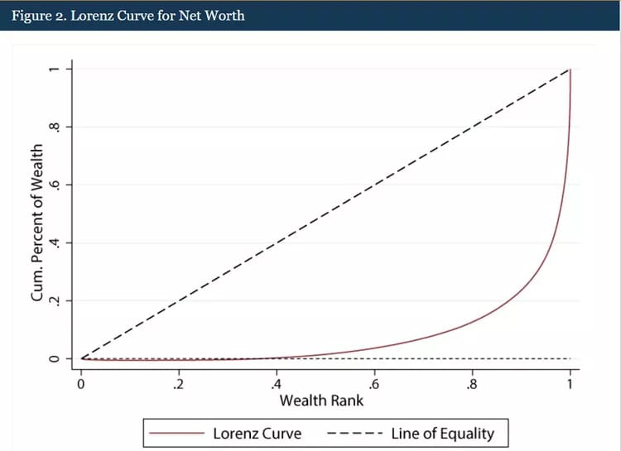The Gini coefficient (discussed below) is the gap between the line of equality and the Lorenz curve.

THANK YOU!!